KINGSTON UPON HULL SWIMMING CLUB
(Affiliated to Swim England North-East Region)

Easter A/B Long Course Meet 2027
Level 3 Long Course Meet
Licence No. TBC

Saturday 3rd & Sunday 4th April 2027
Ponds Forge International Sports Centre, Sheffield

ENTRIES OPEN 3rd January 2027 | CLOSING DATE 19th March 2027

KEY MEET INFORMATION
Date | Saturday 3rd & Sunday 4th April 2027
Venue | Ponds Forge International Sports Centre, Sheffield
Pool | 50m pool, 10 lanes, Anti-wave lane ropes, Electronic Timing, Warm Up/Swim Down pool available
Licence | Swim England Level 3 - Licence TBC
Events | 50m, 100m & 200m all strokes and 200m IM  400m Freestyle & 400m IM - 10 years & over only
Age Groups | Open/Male & Female aged 9, 10, 11, 12, 13, 14 & 15 years and over
Age | Age as of 4th April 2027
Entry Fee | £9.00 per event
Awards | 9 years: Medals 1st - 6th, ungraded.  10 - 15+ years: Medals 1st – 3rd in each A & B grade.  Swimmers exceeding the A Grade time will receive a “Speeding Ticket”.
Spectators | Adults: £10 per day / £16 weekend.  Children (5-12y) & Over 65s: £5 per day / £10 weekend.  Under 5s: Free.
Poolside passes | £25 per pass - for qualified Coaches/Team Managers with a current DBS only. Includes poolside access, start lists, online results and lunch.
Entries | All entries to be submitted online via www.openmeets.com. Paper or email entries will not be accepted. Entries are accepted on a first-come, first-served basis.  Poolside entries: £9.50 per event, at the Promoter’s discretion and subject to availability.
Closing Date | Friday 19th March 2027, or earlier if the meet is full.
Withdrawals & Refunds | Withdrawals must be submitted through Open Meets or via the check-in sheets on the day. No refunds will be made after the closing date or once the meet is full, except for withdrawals on medical grounds where proof is provided.
Payment | Entry fees must be paid by BACS to Kingston upon Hull Swimming Club  HSBC | Sort Code: 40-25-49 | Account No: 50118575 and must include the meet reference: Easter27yourclubname  Entry Summary Sheet and Coach/Team Manager Pass Sheet to be emailed to kuhscopenmeets@gmail.com
Meet enquiries | kuhsctrustees@outlook.com

Schedule of Events

Saturday 3rd April 2027
Session One  Warm-up 8:00am • Start 9:00am  101 MIXED 400m FREE  102 FEMALE 50m BREAST  103 OPEN/MALE 50m FLY  104 FEMALE 100m BACK  105 OPEN/MALE 100m FREE  106 FEMALE 200m FREE  107 OPEN/MALE 200m BACK | Session Two  Warm-up 1:00pm • Start 2:00pm  201 FEMALE 200m IM  202 OPEN/MALE 200m BREAST  203 FEMALE 50m BACK  204 OPEN/MALE 50m FREE  205 FEMALE 100m FREE  206 OPEN/MALE 100m FLY  207 FEMALE 200m FLY

Sunday 4th April 2027
Session Three  Warm-up 8:00am • Start 9:00am  301 MIXED 400m IM  302 OPEN/MALE 50m BREAST  303 FEMALE 50m FLY  304 OPEN/MALE 100m BACK  305 FEMALE 100m BREAST  306 OPEN/MALE 200m FREE  307 FEMALE 200m BACK | Session Four  Warm-up 1:00pm • Start 2:00pm  401 OPEN/MALE 200m IM  402 FEMALE 200m BREAST  403 OPEN/MALE 50m BACK  404 FEMALE 50m FREE  405 OPEN/MALE 100m BREAST  406 FEMALE 100m FLY  407 OPEN/MALE 200m FLY

400m events: Open to swimmers aged 10+ only. Upper cut-off times apply and the number of heats is limited.

MEET & COMPETITION INFORMATION
- The meet is held under Swim England Regulations and Technical Rules of Swimming and will be licensed at Level 3 for inclusion in British Swimming Rankings.
- The Promoter is Sarah Clausen on behalf of Kingston upon Hull Swimming Club.
- Events will be swum in the order shown in the published programme. All individual events are Heat Declared Winner (HDW) and heats will be seeded according to submitted entry times.
- The one start rule will apply. Over-the-top and side-by-side starts may be used at the Promoter’s discretion.
- A secondary start strobe will be available. Where required, the Lead Referee must be notified before the start of warm-up for the relevant session.
ELIGIBILITY, AGE GROUPS & CATEGORIES
- Age groups are 9, 10, 11, 12, 13, 14 and 15+, based on the swimmer's age on 4th April 2027.
- The 400m Freestyle and 400m Individual Medley are open to swimmers aged 10 years and over. The Promoter reserves the right to limit entries in these events.
- The Female category is for birth sex females in accordance with Swim England’s Transgender and Non-Binary Competition Policy. By entering the Female category, a swimmer confirms that their birth sex is female.
ENTRIES, ENTRY TIMES & CUT-OFF TIMES
- Application for entry must be correctly submitted by the specified date and accepted by the Promoter.
- Entries will be accepted on a first come, first served basis until Friday 19th March 2027, or until the meet reaches capacity, whichever occurs first. The Promoter reserves the right to reject or restrict entries to ensure the safe and effective running of the meet.
- A valid entry time must be submitted for every event. Entries submitted as No Time (NT) will not be accepted.
- Entry times should, where available, be taken from British Swimming Rankings. Long Course times should be used where available; Short Course converted times are also accepted.
- Where a swimmer does not have a ranked time, a coach-estimated time may be submitted.
- Entry times must not be faster than the published Upper Cut-Off Times. Swimmers must not have swum faster than the applicable Upper Cut-Off Time in the previous 12 months. Submitted times may be checked against Swim England Rankings.
- Time-only swims faster than the published Upper Cut-Off Time are not permitted.
- Entry times are the responsibility of the entering club and may be updated where permitted by the online entry system.
- The 400m events are subject to Upper Cut-Off Times and limited heats.
- All entries must be submitted through the Open Meets website. Paper and email entries will not be accepted.
- Clubs, swimmers and parents are responsible for checking published accepted entries and reporting any errors or omissions promptly. Errors will not be corrected on the day of meet unless this is proven to be on the part of the meet administration team.
- All meet communication will be via the website and email. Accepted entries will be published on the website and any rejected entries notified by email.
AWARDS
- Medals will be awarded to the top 3 swimmers in each age group and A/B grade, except for the 9-year age group, where medals will be awarded 1st - 6th ungraded.
- Swimmers exceeding the published ULT by greater than one second in 50m and 100m races, 2 seconds in 200m and 400m races will receive a “Speeding Ticket”.
- Awards may be collected from the medal stewards once the relevant results have been confirmed.
WITHDRAWALS, REJECTIONS & REFUNDS
- Withdrawals should be submitted through Open Meets before the competition or using the designated withdrawal/check-in procedure on the day.
- Entry fees for entries rejected by the Promoter will be refunded.
- No refunds will be made for accepted entries withdrawn after the meet closes, except on medical grounds where appropriate evidence is provided.
- If the competition is cancelled, the Promoter's liability will be limited to the refund of entry fees. No other costs will be reimbursed.
PARA SWIMMING
- Para swimmers of a suitable standard to compete in a 50m pool are welcome to enter. Swimmers with a disability will swim under IPC Rules.
- Para swimmers will compete within the main programme and will be seeded according to submitted entry times. Separate qualifying times and award categories will not apply.
- Para swimmers will be included within the results for their relevant age group.
COACHES, TEAM MANAGERS & POOLSIDE ACCESS
- Only swimmers and authorised officials, coaches, team managers, chaperones and other accredited personnel may access poolside.
- Coaches, Team Managers, Chaperones and Personal Care Assistants requiring poolside access must meet the applicable Swim England safeguarding and DBS requirements and must display their issued pass.
- Clubs are responsible for the supervision, whereabouts and behaviour of their swimmers throughout the competition. KUHSC cannot accept responsibility for unaccompanied swimmers.
- Swimmers must report to the competitor stewards in sufficient time for their race. Heats will not be delayed for missing swimmers.
- Suitable footwear and clothing must be worn when leaving poolside. Personal belongings are left at the owner’s risk. The Promoter and venue accept no responsibility for lost, damaged or stolen items.
OFFICIALS
- Visiting clubs are requested to provide at least one licensed official for every 10 swimmers entered.
- Names, SE number and qualification of officials should be emailed to kuhsctrustees@outlook.com before the meet. Training opportunities may be available by prior arrangement. Thank you in advance for your support.
- Officials’ Expenses: KUHSC will reimburse reasonable expenses incurred by officials supporting the meet in accordance with the KUHSC Expenses Policy. This includes eligible travel expenses and, where lunch is not provided by the Club, a meal allowance may be claimed. The full KUHSC Expenses Policy and Expenses Claim Form will be provided in advance to all officials signed up to officiate and will also be available at the meet. Full details of eligible expenses, allowances and claim requirements are set out within the policy.
PHOTOGRAPHY & MOBILE DEVICES
- Mobile phones, cameras and other image-recording devices must not be used on the poolside or in the changing rooms.
- Photography and filming at the competition will be subject to the applicable Swim England and venue requirements communicated for the meet.
- An official event photographer may be present. Information regarding photography arrangements and how to raise any concerns will be communicated before or at the competition.
DATA & GENERAL CONDITIONS
- GDPR: By entering this competition, participants acknowledge that personal information may be processed and published for the administration of the competition, insurance, licensing and publication of results, and may be shared with the governing body or affiliated organisations for these purposes. Published information may include name, club affiliation, age category, entry times and results.
- Submission of an entry through the Open Meets constitutes acceptance of these meet conditions.
- The Referee’s decision is final. Any matters not covered by these conditions will be determined by the Promoter, in consultation with the Lead Referee where appropriate.

A Grade Cut-Off Times
No A Grade cut-off times apply to the 9- and 10-year age groups.
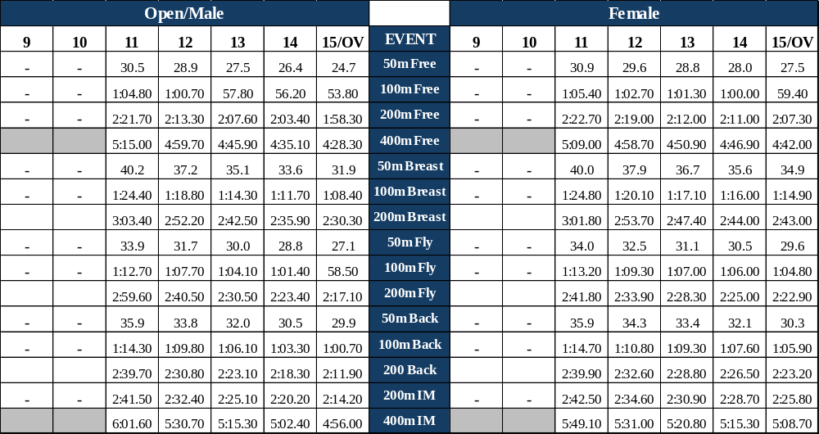
.

B Grade Cut-Off Times
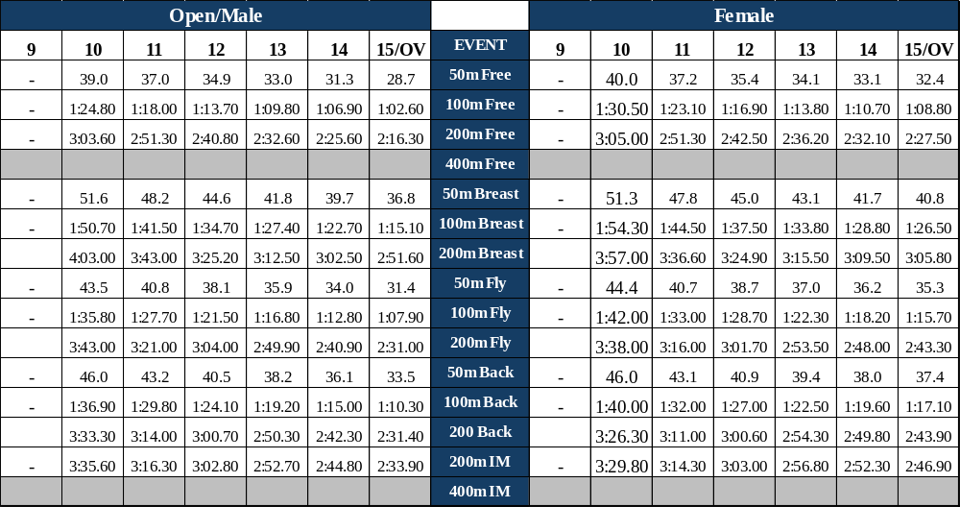
No B Grade cut-off times apply to the 9-year age groups.

Swimmers must not have swum faster than the Upper Limit Time in the previous 12 months.
SHORT COURSE (25m) Converted Times will also be accepted for entry, whichever is quicker
Club Electronic Entry Summary Sheet
Payments via BACS to Kingston upon Hull Swimming Club
Account No 50118575 Sort Code 40-25-49 Reference: Easter27yourclubname
Club
Club Contact
Email Address
Entries | Quantity | Rate | Sub Total
Female Entries |  | £9.00 | £
Open/Male Entries |  | £9.00 | £
TOTAL No ENTRIES |  | TOTAL ENTRIES | £
Coach / TM Passes |  | £25.00 | £

TOTAL PAYMENT: £
Coach / Team Manager Pass Information (passes will not be processed without this information)
Name | Position | Swim England Membership Number | Dietary Requirements
By submitting this information, the club confirms that all Coaches / Team Managers listed meet the applicable DBS and Swim England safeguarding requirement.
Please return this summary with Coach / Team Manager information to kuhscopenmeets@gmail.com.

